PROJECT DOCUMENTATION
LIBSPACE


1.INTRODUCTION:
Project Title: LIBSPACE
Team ID: NM2025TMID38525

Team Leader: SRI VISHNUPRIYA A & srivishnupriya48@gmail.com [Coder] Team Members & [Roles]:
- SHREEYA M & shrezz.2430@gmail.com [Coder]
- SARMITHA A & sarmitha516@gamil.com [Documenter]
- SANDHIYA E & tamilsan2212@gmail.com [Video Recorder]

2. PROJECT OVER VIEW:

- Purpose: Lib Space is a digital platform designed to manage library activities efficiently.
It helps students and librarians to search, borrow, and return books easily. The system reduces manual paperwork and saves time. It also maintains accurate records of books and members.

Features:
- User registration and login system
- Allows users to create an account and securely log in to the system.

- Book search by title, author, or category
- Helps users quickly find books available in the library database.
- Issue and return book management
- Records which user borrowed a book and the return date.
- Fine calculation for late returns
- Automatically calculates the penalty when books are returned after the due date.
- Admin dashboard to manage books and users
- Enables the admin to add, update, or delete book and user records.

3.ARCHITECTURE :

- Backend: Backend is the server-side part of the system that handles business logic and processes user requests. It manages authentication, book issue/return operations, fine calculation, and communication with the database.

  - Node.js (with Express.js) — Lightweight, fast, and great for JavaScript-based stacks.
  - React.js—React.js (commonly referred to as React) is an open-source JavaScript library used for building user interfaces (UIs), especially for single-page applications (SPAs).
- Data base: Database is used to store and manage all application data securely. It keeps records of users, books, transactions, and fines.

  - Mongo DB—Mongo DB Is A No SQL Database That Stores Data In A Flexible,
Document-Oriented Format, Using JSON-Like Documents (Called BSON — Binary JSON)
- Mongo DB stores user details, book records, and transaction information efficiently.

4.ROLES AND RESPONSIBILITIES:
• User Authentication – Handles user registration, login, and logout using secure authentication (JWT tokens).
• Book Management – Allows adding, updating, deleting, and viewing books in the library system.
• Database Management – Connects the application to the database and manages storing and retrieving user and book data.
• API Routing – Defines and manages API endpoints that connect user requests to the correct controllers.
• Security & Middleware – Verifies authentication tokens and protects private routes from unauthorized access.
• Token Blacklisting – Stores invalid or logged-out tokens to prevent reuse and improve system security.
• Server Management – Initializes the server, connects routes, and runs the backend application.
• Environment Configuration – Uses environment variables to securely store sensitive information like database URLs and secret keys.

4. SETUP INSTRUCTIONS :

• Prerequisites:
- Node.js
- Mongo DB
- Git hub
- React.js
- Express.js
- Mongoose
- Visual Studio Code

5.INSTALLATION STEPS:
▪ Clone the repository
git clone <repo-url>
▪ Navigate to the backend folder
cd server
▪ Install dependencies
npm install

6. FOLDER STRUCTURE
LIBSPACE-CODE/
│
├── Config/
│ └── db.js
│
├── controller/
│ ├── authController.js
│ └── bookController.js
│
├── middlewares/
│ └── verify_token.js
│
├── models/
│ ├── blackListerToken.js
│ ├── book.model.js
│ └── user.model.js
│
├── node_modules/
│
├── routes/
│ ├── book.route.js
│ └── user.route.js
│
├── .env
├── .gitignore
├── index.js
├── package-lock.json
├── package.json
└── README.md

7. RUNNING THE APPLICATION :
Start MongoDB service
▪ Run the backend server
cd server
npm start
▪ Server will run at
http://localhost:5000

7. AUTHENTICATION :
- protect library data and user information
- Allow only registered users to access the system
- Control permissions for different roles (admin, librarian, student)
- Prevent unauthorized access to the library system
- Maintain system security and track user activities

8. API DOCUMENTATION:
USER APIs
- POST/api/user/register-register a new user
- POST/api/user/login- login user

Book APIs
- POST/api/books/add-add new book
- GET/api/books-get all books
- PUT/api/books/:id-update book details
- DELETE/api/books/:id- delete a book
ISSUE/RETURN APIs
- POST/api/issue- issue a book
- PUT/api/return/:id- issue a book
- GET/api/issue/history- view issue history

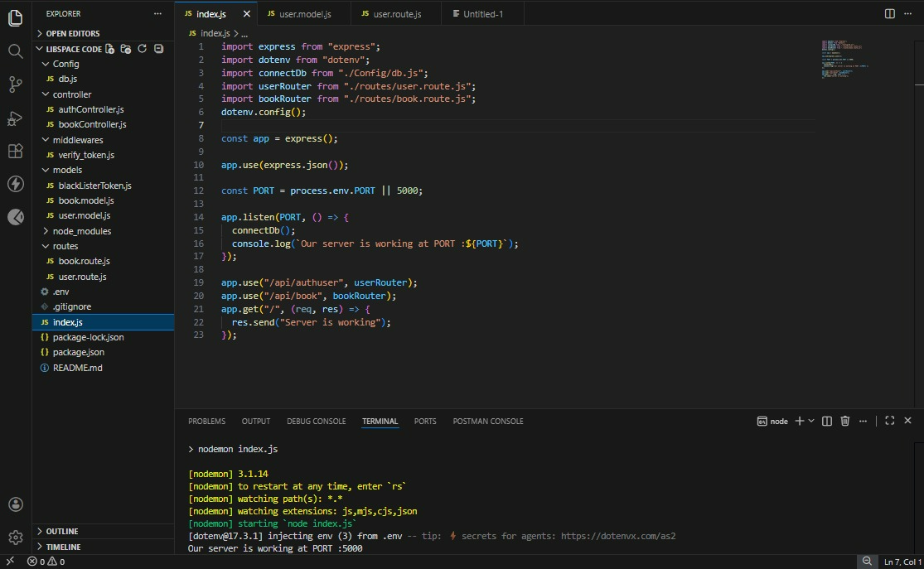

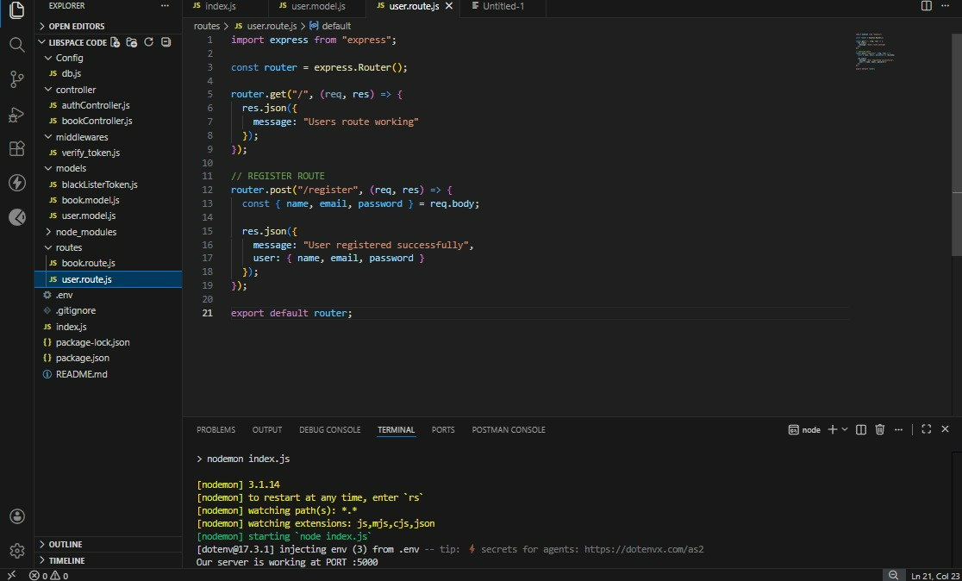

USER INTERFACE:
USER REGISTER:
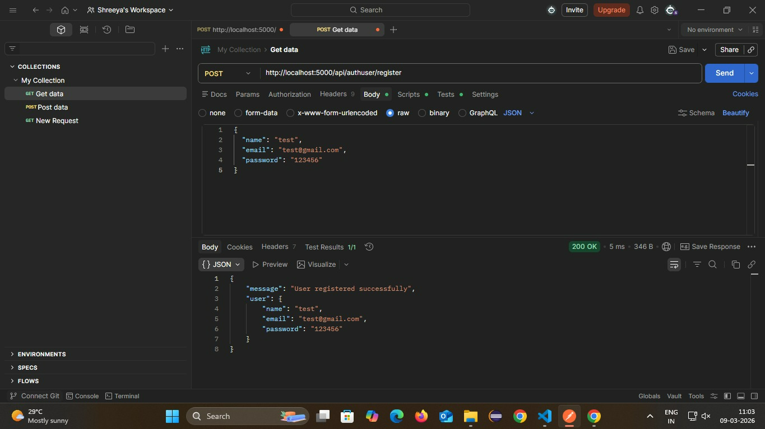

USER LOGIN:
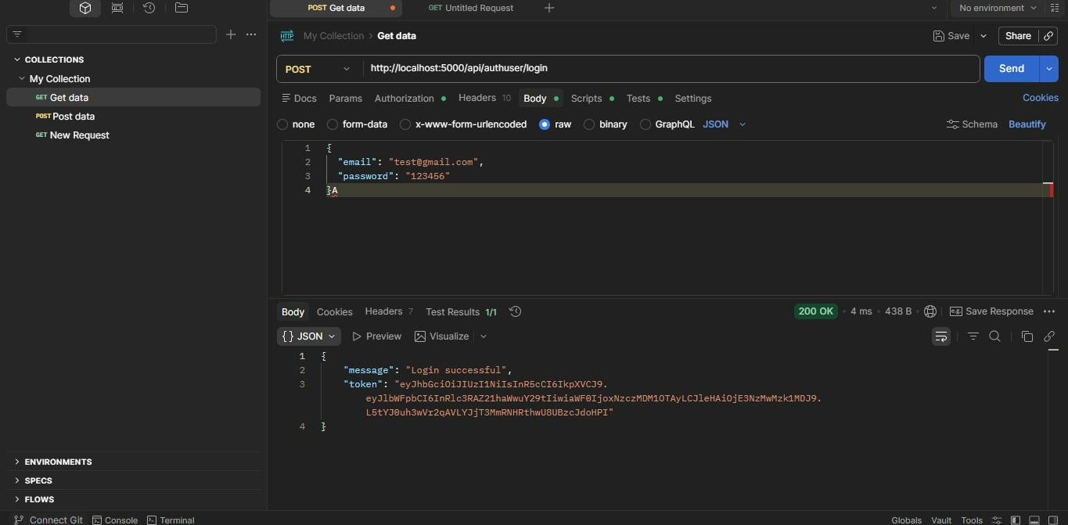

ADDING BOOKS:
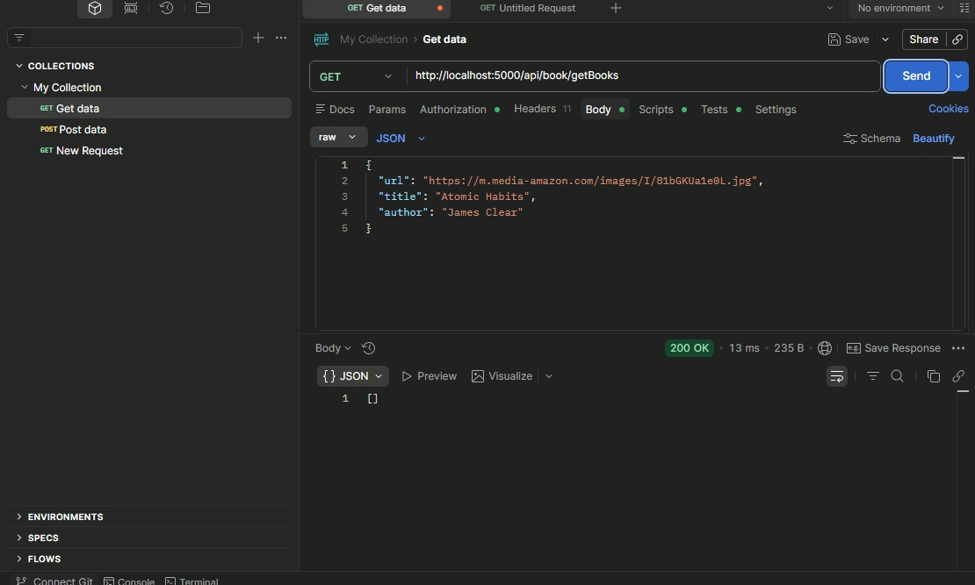

9. VIDEO :
https://drive.google.com/file/d/1Gj2rri8ek8o9BiMXujwGaPNt2LWPbZzT/view?usp=drivesdk

10. KNOWN ISSUES :

1. Slow System Performance 🐢
- The system may become slow when many users access it at the same time.
- Searching books or loading pages can take longer during peak hours.

2. Technical Errors or System Crashes 💻
- The software may freeze or crash during operations such as book issue/return.
- Sometimes modules like circulation or seat booking may stop responding.

3. Difficult User Interface
- Some users find the interface complicated and hard to navigate.
- Too many menus and options make it difficult for librarians or students to use efficiently.

4. Limited Mobile Compatibility 📱
- Some systems are not fully optimized for mobile devices.
- Students may face issues accessing the system through smartphones.

5. Data Errors or Incorrect Records
- Problems like:
  - Wrong inventory counts
  - Missing data after updates
  - Incorrect user records

6. Limited Analytics and Reporting 📊
- Some systems provide limited reports and statistics.
- Real-time data about library usage or space utilization may not always be available.
- Authentication, Authorization, and Known Issues in short 2-mark answers.

11. FUTURE ENHANCEMENT :
- Mobile Application Support
- Online Seat and Room Booking System
- Advanced Analytics and Reports
- Integration with Other Library Systems
- Notification and Alert System
- Improved Security and Authentication

